DBMS LAB MIDSEM EXAM

Name:- Bibek Chand Sah Roll No. 22054029

1. Create a new user and grant all privileges to it. Your username should be your father’s name and your password should be your mother’s name. After the user is created, log in to that user. [1]

🡺 create user kamal identified by kamali;

grant all privileges to kamal;

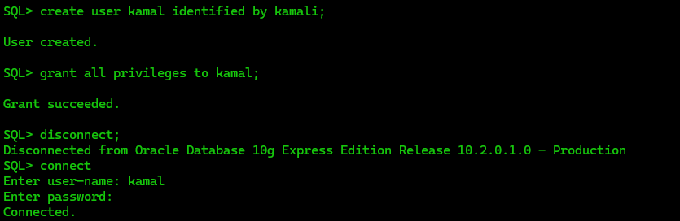

2. Create a table student_last_3_digits_of_your_roll_no (e.g. student_007) with attributes roll_no, f_name , l_name , d_name, and cgpa. [1]

🡺 CREATE TABLE student_029 (roll_no INT, f_name VARCHAR(25), l_name VARCHAR(25), d_name VARCHAR(25), cgpa DECIMAL(3, 1));

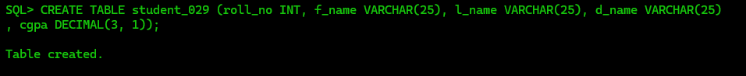

3. Create another table department_last_3_digits_of_your_roll_no (e.g. deoartment_203) with attributes d_name, d_loc, no_of_faculty, hod_id.[1]

🡺 CREATE TABLE department_029 ( d_name VARCHAR(25), d_loc VARCHAR(25), no_of_faculty INT, hod_id VARCHAR(25));



4. Make the hod_id attribute in the department table unique. [1]

🡺ALTER TABLE department_029 ADD CONSTRAINT unique_hod_id UNIQUE (hod_id);



5. Add an attribute ph_no in the student table, which should have a unique

constraint on it. [1]

🡺 ALTER TABLE student_029 ADD ph_no INT UNIQUE;

6. Make the ph_no attribute NOT NULL. [1]

🡺 ALTER TABLE student_029 MODIFY ph_no INT Not Null;

7. Make the d_name attribute in the student table a foreign key referencing the d_name attribute in the department table. [1]

🡺

alter table department_029 add constraint pk_key primary key (d_name);

alter table student_029 add constraint fk_key foreign key (d_name) references department_029 (d_name);

8. Enter the following tuples into the department table. [1]

|  |  |  |  |
| --- | --- | --- | --- |
| d_name | d_loc | no_of_faculty | hod_id |
| cse | campus_15 | 100 | f_789 |
| it | campus_14 | 45 | f_1009 |
| csse | campus_12 | 34 | f_646 |

🡺

INSERT INTO department_029(d_name, d_loc, no_of_faculty, hod_id) VALUES ('&d_name', '&d_loc', &no_of_faculty, '&hod_id');

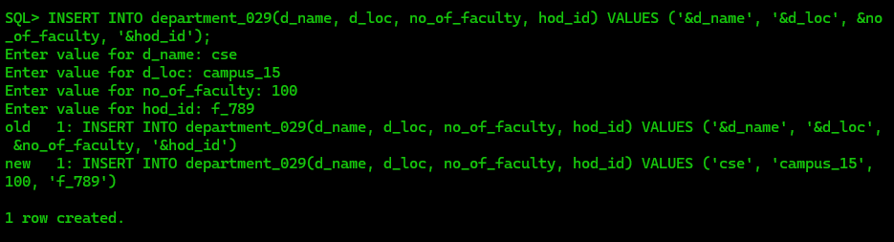

9. Enter the following tuples into the student table. [1]

|  |  |  |  |  |  |
| --- | --- | --- | --- | --- | --- |
| roll_no | f_name | l_name | d_name | cgpa | ph_no |
| 1001 | Atul | Yadav | cse | 8.9 | 555 |
| 1002 | Bipasa | Sharma | it | 7.9 | 666 |
| 3001 | Sunil | Sahoo | csse | 8.0 | 777 |
| 3002 | Eleena | Winget | csse | 8.5 | 888 |
| 3003 | Asha | Verma | csse | 7.5 | 999 |

🡺

INSERT INTO student_029 (roll_no, f_name, l_name, d_name, cgpa, ph_no) VALUES (1001, 'Atul', 'Yadav', 'cse', 8.9, 555);

INSERT INTO student_029 (roll_no, f_name, l_name, d_name, cgpa, ph_no) VALUES (1002, 'Bipasa', 'Sharma', 'it', 7.9, 666);

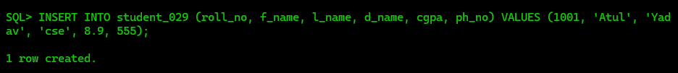

10. Update the location of IT department to campus_3. [1]

🡺UPDATE department_029 SET d_loc = 'campus_3' WHERE d_name = 'it';

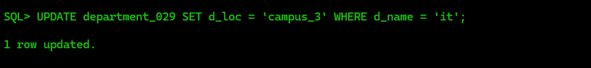

11. Project the department names and their average cgpa. [1]

🡺SELECT d_name, AVG(cgpa) AS avg_cgpa FROM student_029 GROUP BY d_name;

12. Display the student details whose f_name starts with ‘a’ and ends with ‘a’. [1]

🡺SELECT * FROM student_029 WHERE f_name LIKE 'a%a';

13. List the names of the students who come in the control of hod_id f_646. [1]

🡺SELECT f_name, l_name FROM student_029 WHERE d_name IN (SELECT d_name FROM department_029 WHERE hod_id = 'f_646');

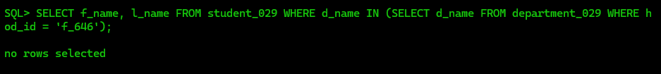

14. Make {f_name,l_name} the primary key of the student table. [1]

🡺 ALTER TABLE student_029 ADD CONSTRAINT pk_name PRIMARY KEY (f_name, l_name);

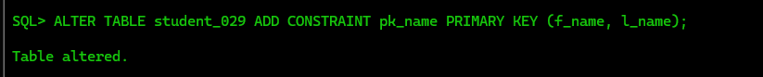

15. Rename the ph_no attribute to whatsapp. [1]

🡺ALTER TABLE student_029 RENAME COLUMN ph_no TO whatsapp;

